
JC2 PRELIMINARY EXAMINATION
TAMPINES MERIDIAN JUNIOR COLLEGE

CANDIDATE
NAME
CIVICS GROUP
_________________________________________________________________________________
H2 GEOGRAPHY 9173/01
Paper 1 17 September 2026 3 Hours

INSERT
___________________________________________________________________________

READ THESE INSTRUCTIONS FIRST

This Insert contains all the Resources referred to in the questions.

_________________________________________________________________________________

This document consists of 7 printed pages and 1 blank page.
Resource 1 for Question 1
Tesla’s operations throughout the world
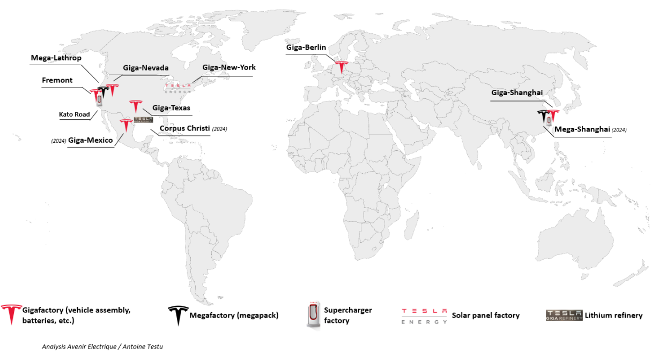

Resource 2 for Question 1
Component suppliers for Tesla cars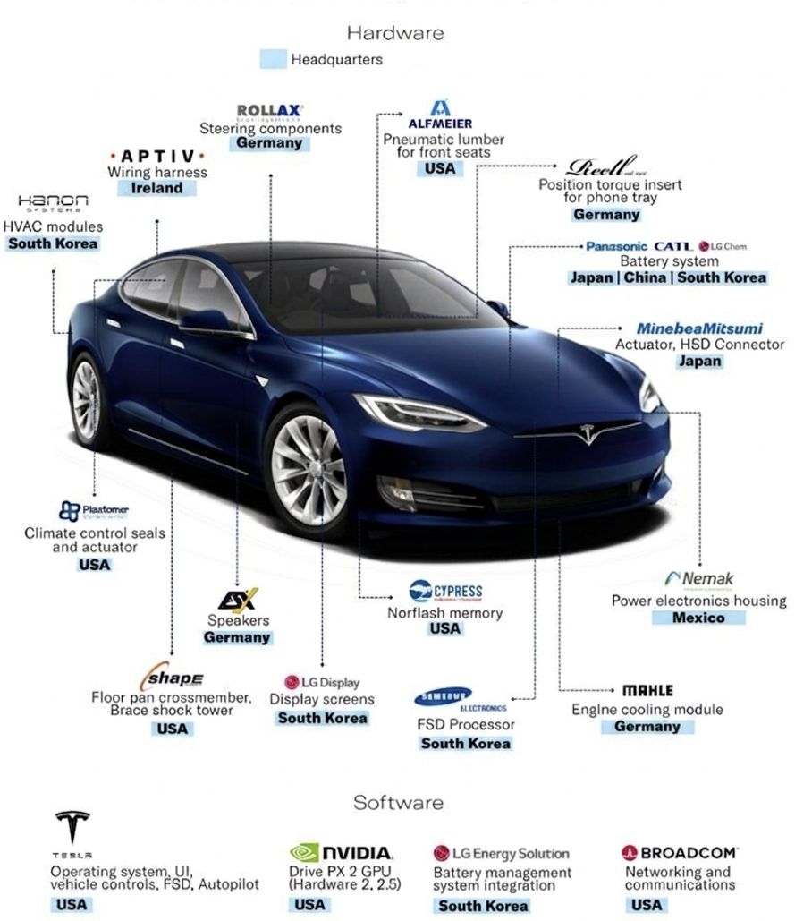

Resource 3 for Question 1
Annual battery electric passenger vehicle sales of Tesla and BYD

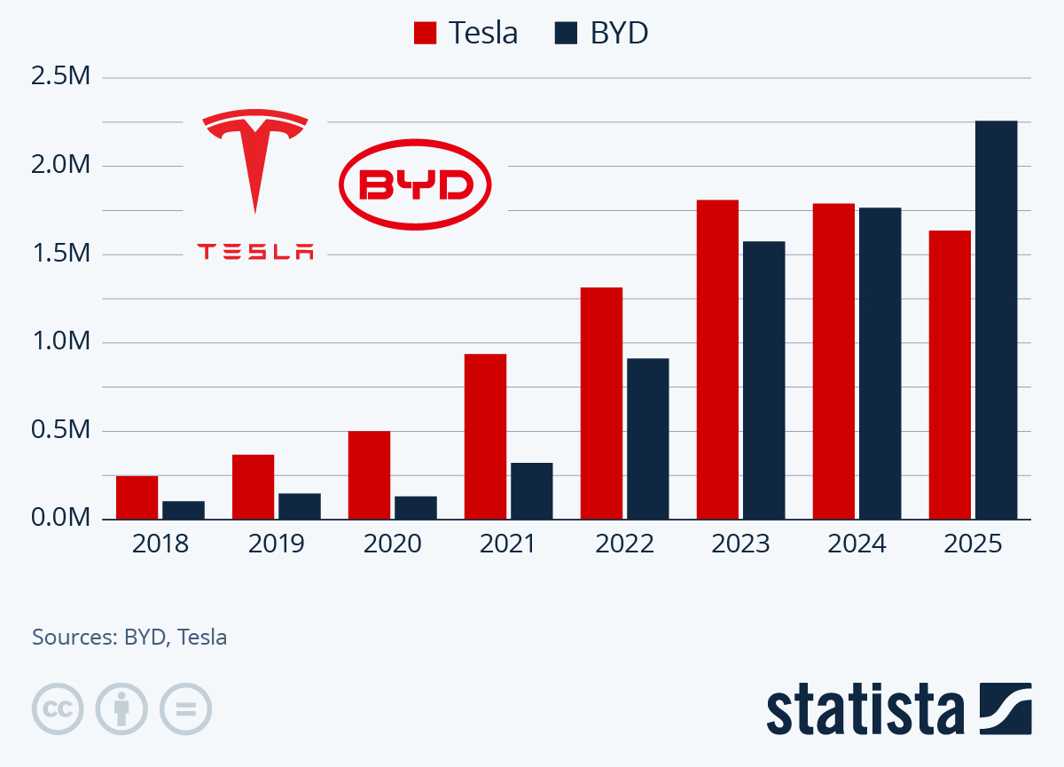

Resource 4 for Question 2
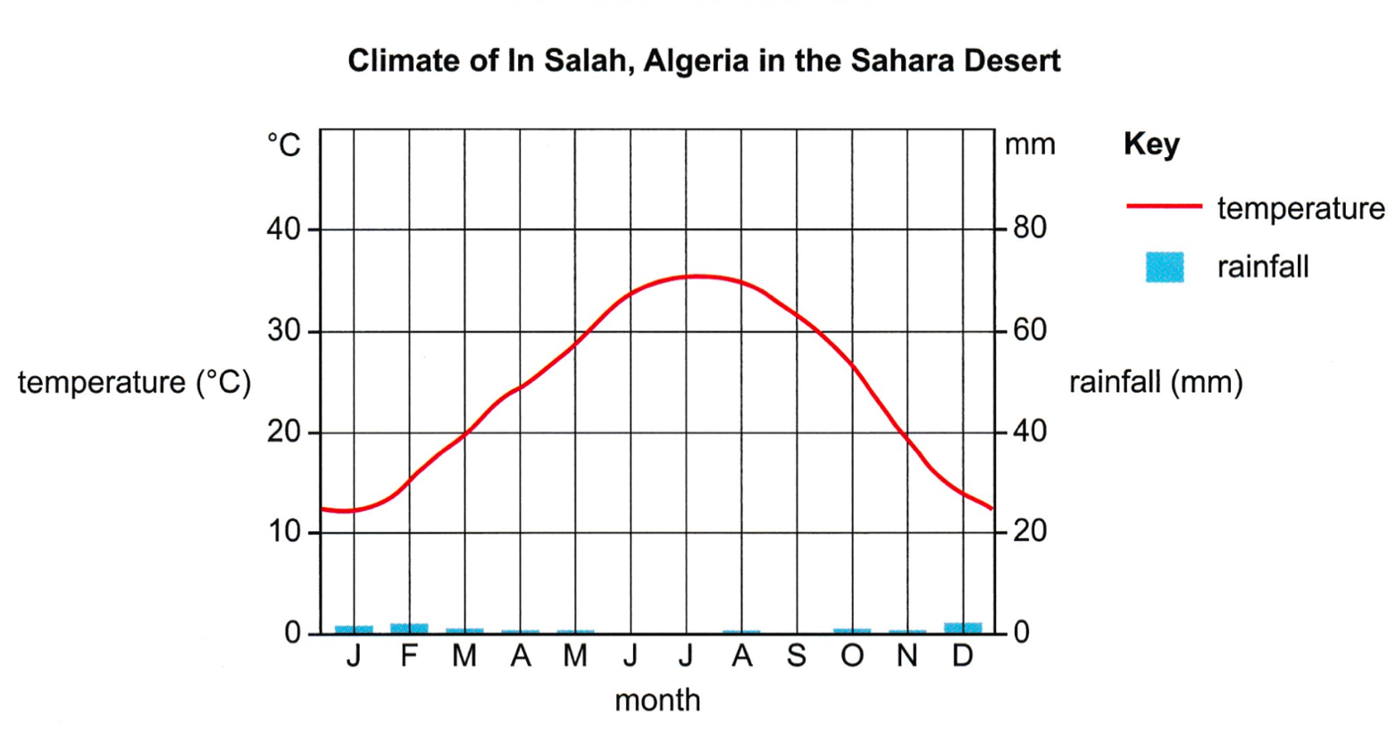

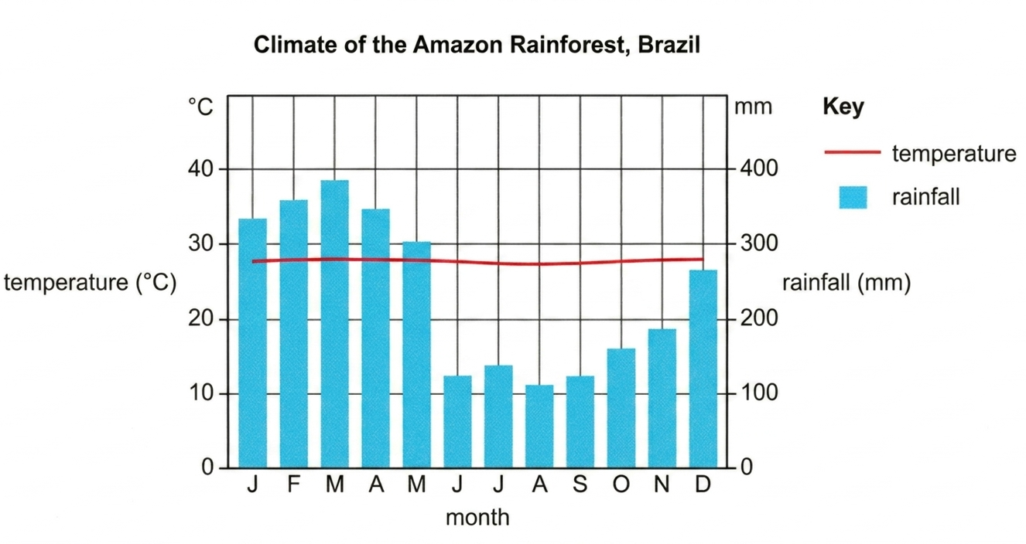
Resource 5 for Question 2
Section of the Amazon River

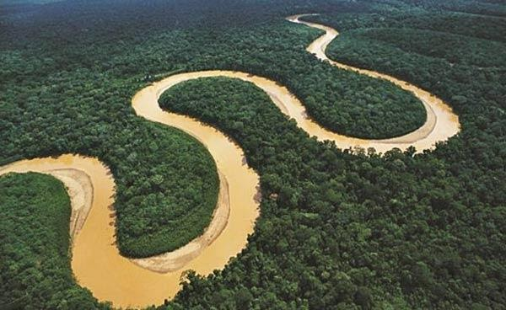

Resource 6 for Question 2
Areas of deforestation in the Amazon Rainforest, South America

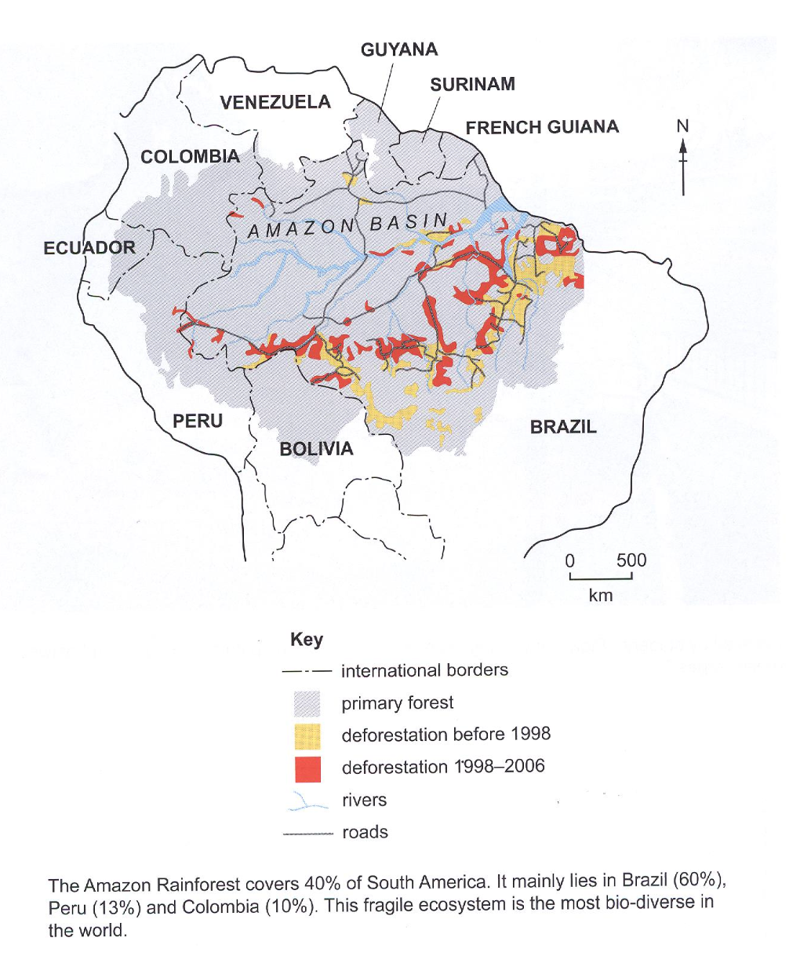

BLANK PAGE

